

**C. K. Pithawalla College Of Commerce**

**Managment Computer Application**

**Bachelor of Computer Application (BCA)**

**TYBCA SEMESTER – VI (Div :- B)**

**Affiliation Year :- 2024-25**

**Project :- Tour And Tourism Guide**

**By**

1. **Zanzmera Pooja - 278**
2. **Gohil Divyraj - 208**
3. **Vamja Vardhit - 270**

**Guided by:**

**Dr.Ami Desai**

INDEX

1. INTRODUCTION: 3

1.1 Project Profile 3

1.2 Project Introduction 3

2. Environment Description: 5

2.1 Hardware and Software Requirements 5

2.2 Technology Used 6

3. Existing System 8

3.1 System Components 8

3.2 Drawbacks of Existing System 8

4. System Planning 10

4.1 Feasibility Study 10

4.2 Requirement Analysis and Data Gathering 11

5. Proposed System 13

5.1 Scope 13

5.2 Objectives 14

5.3 Constraints 14

5.4 Expected Advantages 15

6.Detail Planning 16

6.1 UML Diagram 16

6.2 Entity-Relationship Diagram 19

6.3 Process Specification 20

7.System Design 23

7.1 Table description 23

7.3 Screenshots 25

8.Software Testing 38

8.1 Test Case 38

9. Conclusion and future enhancement 41

10. References 44

1. INTRODUCTION:

## 1.1 Project Profile

**Project Title**: Tour and Tourism Guide

**Team Members**: [Your Name]

**Technologies Used**: PHP, MySQL, HTML, CSS, JavaScript, Bootstrap  
**Database**: MySQL

**Web Server**: Apache

**Duration**: [Specify the duration of the project, e.g., 3 months]

The "Tour and Tourism Guide" is a dynamic website specifically focused on tourism in India. The platform provides users with detailed information about tourist destinations across various Indian states. The system allows users to explore, plan, and book trips, offering day-by-day itineraries along with necessary travel details, including accommodation, food, and transportation costs.

## 1.2 Project Introduction

The "Tour and Tourism Guide" is an online platform designed to help tourists explore famous destinations within India and book tours. The website offers a user-friendly interface where users can browse state-wise tours or explore comprehensive all-India tours. Each tour package comes with detailed information about daily activities, places to visit, hotels, restaurants, transportation options, and estimated costs per day or for the entire tour.

**Key features of the system include:**

* **State-wise Tour Packages**: Users can select from tours specific to various Indian states (e.g., Rajasthan, Kerala, Himachal Pradesh) based on their travel preferences.
* **All-India Tours**: For users interested in exploring multiple states, there are packages that cover famous destinations across India, offering a complete travel experience.
* **Detailed Itinerary**: Each tour package includes a day-by-day plan, outlining places to visit, how to reach each location, accommodation options, dining recommendations, and expected costs.
* **User Authentication**: To book a tour, users must first register or log in to the platform, ensuring personalized experiences and booking management.
* **Booking System**: Once logged in, users can book their chosen tour packages. The system provides information on pricing, availability, and contact details for tour operators.

This project caters to domestic and international tourists seeking to explore India, with comprehensive support for planning and booking customized tours.

2. Environment Description:

## 2.1 Hardware and Software Requirements

**Hardware Requirements**:

* **Client-Side**:  
  Users accessing the "Tour and Tourism Guide" website need an internet-enabled device with a browser. The website is compatible with most modern web browsers like Google Chrome, Mozilla Firefox, and Microsoft Edge.
* **Server-Side**:

The server hosting the website requires at least 1GB of disk space to manage files, databases, and user-generated content. The server must be capable of running PHP-based applications and supporting MySQL databases.

* **Development Environment**:

The development of the project was carried out using Visual Studio Code (VS Code) as the code editor. The website was developed and tested on a local server using XAMPP, which provides a cross-platform development environment. The project can be developed and run on both Windows and macOS systems.

**Software Requirements**:

* **Operating System**: Windows (for development and testing)
* **Web Server**: Apache (provided by XAMPP)
* **Database**: MySQL
* **PHP Version**: 5.2.1
* **Development Tools**: Visual Studio Code, XAMPP for local server setup
* **Browser**: Any modern browser with JavaScript enabled (Google Chrome, Mozilla Firefox, etc.)

## 2.2 Technology Used

**Backend**:

* **PHP (Version 5.2.1)**:

PHP is used as the server-side scripting language to handle dynamic content, process user inputs, manage sessions, and interact with the database.

* **MySQL**:

MySQL is the database management system used to store user information, tour packages, bookings, and other data. The database is structured to efficiently handle relational data between users, destinations, and bookings.

**Frontend**:

* **HTML/CSS**:

HTML is used for structuring the content of the website, and CSS is used to style the front-end pages, ensuring a clean and user-friendly design.

* **JavaScript**:

JavaScript is used to add interactivity to the website, such as form validation, dynamic content updates, and improved user experiences.

* **Bootstrap**:

The Bootstrap framework is used for responsive design, ensuring that the website looks good on various devices, including desktops, tablets, and mobile phones.

**Development Tools :-**

* **Visual Studio Code (VS Code)**:

VS Code is the code editor used for writing and managing the project’s code. It offers various extensions that enhance productivity and code management.

* **XAMPP**:

XAMPP provides a local server environment with Apache, PHP, and MySQL, which makes it easy to develop, test, and debug the project locally before deployment.

3. Existing System

## 3.1 System Components

The existing systems, such as **holidaynights.com** and **tourmyindia.com**, serve as online platforms to help users explore and book tour packages across various destinations. These platforms typically have the following components:

1. **Tour Listings**: Provide a catalog of tours, typically arranged by location or type of experience (adventure, cultural, etc.).
2. **User Accounts**: Allow users to register and log in to book tours and manage their bookings.
3. **Booking System**: After selecting a tour, users can make a booking through the platform, often with options for payments.
4. **Tour Information**: Display general information about destinations, hotels, and activities included in the tour packages.
5. **Reviews and Ratings**: Allow users to review and rate the tours, giving insights into user experiences.

## 3.2 Drawbacks of Existing System

While these platforms offer basic features, they face several limitations:

* **Lack of Detailed Information on Rare Destinations**: Some primarily focus on well-known tourist spots. However, they lack in-depth information on rare or less-explored places in India, leaving users with fewer options for unique travel experiences.
* **Inadequate Budget Transparency**: Existing platforms often provide incomplete or unclear details on the total cost of tours, which can make it difficult for users to plan within their budget. Users may not have a clear breakdown of daily expenses for accommodation, food, and transportation, leading to unexpected costs during their trips.
* **Performance Issues**: The performance of these platforms can be slow due to outdated web technologies and inefficient designs, causing delays in tour searches, booking procedures, and overall navigation.

**How "Tour and Tourism Guide" Improves These Systems:**

1. **Rare Destination Coverage**: The "Tour and Tourism Guide" website addresses the issue of limited information on rare or less-explored destinations by offering comprehensive coverage of such places. Users can access detailed guides even for offbeat locations.
2. **Transparent Budget Planning**: The platform provides detailed cost breakdowns for each tour package, including daily expenses on accommodation, food, transportation, and other activities.

4. System Planning

## 4.1 Feasibility Study

The feasibility study assesses whether the proposed system (the "Tour and Tourism Guide" website) is practical and achievable within the given constraints. This includes evaluating technical, operational, and financial aspects.

**Technical Feasibility**:

* **Technology Stack**: The chosen technologies (PHP, MySQL, HTML, CSS, JavaScript, Bootstrap) are suitable for developing a web-based application and are well-supported. PHP and MySQL are reliable for server-side processing and data management, while HTML, CSS, and JavaScript ensure a responsive and interactive user interface.
* **Development Tools**: Using Visual Studio Code for development and XAMPP for local server setup is practical, given their compatibility with Windows and macOS and their ease of use for development and testing.

**Operational Feasibility**:

* **User Experience**: The website design focuses on user-friendliness and easy navigation, ensuring that users can find and book tours without difficulty. The detailed day-by-day itineraries and transparent cost breakdowns enhance usability.
* **Maintenance**: The system is designed to be maintainable, with clear code organization and the use of standard technologies, which simplifies future updates and troubleshooting.

**Financial Feasibility**:

* **Development Costs**: The development cost includes time invested and the use of open-source technologies, which helps keep expenses low. The primary costs are related to hosting and potential third-party services.
* **Return on Investment**: By addressing gaps in existing platforms and providing detailed, transparent information, the website aims to attract users who are looking for comprehensive tour planning tools, which can drive revenue through bookings.

## 4.2 Requirement Analysis and Data Gathering

Requirement analysis involves identifying what the system needs to achieve and collecting data to support these requirements. For the "Tour and Tourism Guide" website, this involves:

**1. Functional Requirements**:

* **Tour Packages**: Users need to view, filter, and search for state-wise or all-India tour packages.
* **Detailed Itineraries**: Each package should include detailed daily plans, including accommodation, meals, transportation, and costs.
* **User Authentication**: Users must register or log in to book tours, ensuring secure transactions and personalized experiences.
* **Booking and Payment**: Users should be able to book tours online, with secure payment processing and receipt generation.
* **Admin Functionality**: Admins need to manage and update tour packages, review user bookings, and handle system maintenance.

**2. Non-Functional Requirements**:

* **Performance**: The website should load quickly and handle multiple concurrent users efficiently.
* **Security**: User data and payment information must be protected with encryption and secure authentication mechanisms.
* **Scalability**: The system should be designed to accommodate future growth, including additional features or increased user traffic.

**3. Data Gathering**:

* **Market Research**: Collect information on existing tourism platforms to understand their features, strengths, and weaknesses.
* **User Feedback**: Conduct surveys or interviews with potential users to identify their needs and preferences regarding tour planning and booking.
* **Technical Requirements**: Gather technical specifications for server requirements, software dependencies, and development tools to ensure compatibility and performance.

**4. Documentation**:

* **Requirements Specification**: Document all functional and non-functional requirements in detail.
* **Data Sources**: Record sources of data used for analysis, including market research reports, user surveys, and technical documentation.

This structured approach to feasibility study and requirement analysis helps ensure that the "Tour and Tourism Guide" website is practical, meets user needs, and can be developed and maintained efficiently.

5. Proposed System

## 5.1 Scope

**Scope** defines the boundaries of the project, including what it will cover and any limitations.

* **Tour Coverage**: The website will offer detailed information and booking options for both state-wise and all-India tours, focusing exclusively on destinations within India.
* **User Features**: Users can browse tour packages, view detailed itineraries, and book tours. They will need to register or log in to complete bookings and will receive a receipt upon successful payment.
* **Admin Features**: Admins will have the ability to add, update, and manage tour packages, view user bookings, and generate reports.
* **Technical Scope**: The website will be developed using PHP, MySQL, HTML, CSS, and JavaScript, and will be hosted on a server with at least 1GB of disk space. It will be accessible via modern web browsers on both Windows and macOS.

**Limitations**:

* **Geographical Focus**: The website will only cover destinations within India.
* **Platform Limitations**: The system will be optimized for standard web browsers and may not fully support older or less common browsers.
* **Hardware Constraints**: The server has limited disk space (1GB), which might restrict the amount of data and user content that can be stored.

## 5.2 Objectives

**Objectives** outline the goals of the proposed system and what it aims to achieve:

* **Comprehensive Coverage**: Provide detailed and up-to-date information on a wide range of tourist destinations within India, including rare and less-explored places.
* **User-Friendly Interface**: Develop an intuitive and responsive website that allows users to easily browse, select, and book tour packages.
* **Transparency**: Offer clear and detailed cost breakdowns for each tour package, including daily expenses, to help users plan their budget effectively.
* **Secure Booking**: Implement a secure booking system that requires user authentication and provides proof of booking with detailed receipts.
* **Efficient Administration**: Equip administrators with tools to manage tour packages, handle user bookings, and maintain the website efficiently.

## 5.3 Constraints

**Constraints** refer to limitations and restrictions that could impact the project:

* **Budget Constraints**: Limited financial resources for development, marketing, and ongoing maintenance.
* **Time Constraints**: Project deadlines may limit the scope of features that can be implemented or the depth of testing that can be performed.
* **Technical Constraints**: The use of specific technologies (PHP, MySQL) and a server with 1GB of disk space may limit the scalability and performance of the website.
* **User Accessibility**: The website's performance and features may vary depending on the user's device and browser compatibility.

## 5.4 Expected Advantages

**Expected Advantages** highlight the benefits and improvements the proposed system will bring:

* **Detailed Destination Information**: Users will have access to comprehensive guides for both popular and rare destinations, helping them make informed travel decisions.
* **Transparent Pricing**: The platform’s detailed cost breakdowns will provide users with a clear understanding of tour expenses, avoiding unexpected costs.
* **Enhanced User Experience**: The user-friendly interface and secure booking process will improve overall satisfaction and encourage repeat usage.
* **Efficient Administration**: The admin tools will streamline the management of tour packages and user bookings, reducing administrative overhead and improving operational efficiency.
* **Competitive Edge**: By addressing the drawbacks of existing platforms, such as lack of information on rare places and budget transparency, the website will attract users seeking a more comprehensive and reliable travel planning tool.

6.Detail Planning

## 6.1 UML Diagram

**Class-side Diagrams**



**Server-Side diagrams**



Unified Modeling Language (UML) diagrams are essential for visualizing the structure and interactions within a system. For the "Tour and Tourism Guide" website, we will primarily use **Use Case Diagrams** and **Class Diagrams** to represent different aspects of the system.

**Use Case Diagram**:

A Use Case Diagram helps in understanding the functional requirements of the system from the user's perspective. It illustrates the interactions between users (actors) and the system’s functionalities (use cases).

**Actors**:

1. **Guest User**: A visitor who can browse tour packages and view basic information without logging in.
2. **Registered User**: A user who has logged in and can book tours, view booking history, and manage their profile.
3. **Admin**: An administrative user who can manage tour packages, view and manage user bookings, and update system information.

**Use Cases**:

1. **Browse Tour Packages**: Allows both Guest Users and Registered Users to view a list of available tour packages.
2. **View Tour Details**: Lets users view detailed information about a specific tour, including daily itineraries, accommodation, transportation, and costs.
3. **Register / Login**: Enables users to create an account or log in to access booking functionalities.
4. **Book Tour**: Allows Registered Users to book selected tours, including payment processing and receipt generation.
5. **Manage Tours**: Admins can add, update, or remove tour packages and manage tour details.
6. **Manage Bookings**: Admins can view and manage user bookings, including confirmations and cancellations.

**Class Diagram**:

A Class Diagram depicts the static structure of the system, showing classes, their attributes, methods, and relationships. For the "Tour and Tourism Guide" website, key classes include:

1. **User**:
   * **Attributes**: userID, username, password, email, role
   * **Methods**: register(), login(), viewProfile(), updateProfile()
2. **TourPackage**:
   * **Attributes**: tourID, title, description, price, duration, location, itineraryDetails
   * **Methods**: addTour(), updateTour(), deleteTour(), viewTourDetails()
3. **Booking**:
   * **Attributes**: bookingID, userID, tourID, bookingDate, totalCost, status
   * **Methods**: createBooking(), cancelBooking(), generateReceipt()
4. **Admin** (inherits from User):
   * **Attributes**: adminID, adminRole
   * **Methods**: manageTours(), manageBookings(), generateReports()

**Relationships**:

* **User** has a one-to-many relationship with **Booking** (a user can have multiple bookings).
* **TourPackage** has a one-to-many relationship with **Booking** (a tour package can be booked by multiple users).
* **Admin** is a specialized form of **User** with additional capabilities.

**UML Diagram Explanation**: The Use Case Diagram illustrates how different users interact with the system. The Class Diagram shows the core components of the system and their relationships, providing a blueprint for implementation and understanding how different parts of the system will interact.

## 6.2 Entity-Relationship Diagram

An Entity-Relationship (ER) Diagram models the data and relationships between different entities within the system. For the "Tour and Tourism Guide" website, the ER Diagram will include entities like **User**, **TourPackage**, **Booking**, and **Admin**.

**Entities and Attributes**:

1. **User**:
   * **Attributes**: userID (Primary Key), username, password, email, role
2. **TourPackage**:
   * **Attributes**: tourID (Primary Key), title, description, price, duration, location
3. **Booking**:
   * **Attributes**: bookingID (Primary Key), userID (Foreign Key), tourID (Foreign Key), bookingDate, totalCost, status
4. **Admin**:
   * **Attributes**: adminID (Primary Key), userID (Foreign Key), adminRole

**Relationships**:

1. **User to Booking**:
   * **Type**: One-to-Many
   * **Description**: A user can have multiple bookings. The relationship is represented by a line connecting the User entity to the Booking entity, with a 'crow's foot' notation at the Booking end indicating the one-to-many relationship.
2. **TourPackage to Booking**:
   * **Type**: One-to-Many
   * **Description**: A tour package can be booked by multiple users. This relationship is represented similarly with a line and 'crow's foot' notation.
3. **Admin to User**:
   * **Type**: One-to-One (or One-to-Many, depending on implementation)
   * **Description**: An admin is a specialized user with additional privileges. The relationship connects Admin to User with an optional notation indicating that Admin inherits from User, or has a one-to-one relationship if a single admin is associated with a single user account.

**ER Diagram Explanation**: The ER Diagram visually represents the data entities and their relationships, providing a clear view of how data is structured and connected within the system. It helps in understanding the database design and ensuring that all necessary data is captured and related correctly.

## 6.3 Process Specification

Process Specification details the functional processes within the system, describing how the system will handle data and perform tasks. For the "Tour and Tourism Guide" website, we will focus on key processes such as user registration, tour booking, and admin management.

**1. User Registration and Login**

**Registration**:

* **Process**:
  1. **Input**: User submits registration form with username, password, and email.
  2. **Validation**: System checks for existing usernames or email addresses and verifies password strength.
  3. **Encryption**: Password is encrypted using a secure hashing algorithm.
  4. **Storage**: User details are stored in the database under the User entity.
  5. **Confirmation**: User receives a confirmation email or message.

**Login**:

* **Process**:
  1. **Input**: User submits login credentials (username and password).
  2. **Validation**: System verifies credentials against the User database.
  3. **Authentication**: If valid, a session is created for the user.
  4. **Access**: User gains access to the system and can browse and book tours.

**2. Tour Booking**

**Booking Process**:

* **Process**:
  1. **Selection**: User selects a tour package from the list of available tours.
  2. **Details**: User views detailed information about the tour, including itinerary and costs.
  3. **Booking Form**: User fills out booking form with necessary details (e.g., number of people, special requests).
  4. **Payment**: User proceeds to payment, entering payment details through a secure payment gateway.
  5. **Validation**: System verifies payment details and processes the transaction.
  6. **Confirmation**: Upon successful payment, a booking record is created, and the user receives a confirmation receipt.

**3. Admin Management**

**Tour Management**:

* **Process**:
  1. **Input**: Admin adds, updates, or deletes tour packages via the admin dashboard.
  2. **Validation**: System checks for input errors or inconsistencies.
  3. **Update**: Changes are updated in the database under the TourPackage entity.
  4. **Notification**: Users may be notified of new or updated tours.

**Booking Management**:

* **Process**:
  1. **Access**: Admin views and manages bookings through the admin dashboard.
  2. **Actions**: Admin can confirm, cancel, or modify bookings as needed.
  3. **Reporting**: Admin can generate reports on bookings, including statistics and summaries.

**4. Receipt Generation**

**Receipt Process**:

* **Process**:
  1. **Trigger**: Receipt generation is triggered upon successful booking and payment.
  2. **Data**: System collects booking details and payment information.
  3. **Format**: Receipt is generated in a readable format (e.g., PDF) containing tour details, total cost, and transaction ID.
  4. **Delivery**: Receipt is sent to the user’s email and available for download from their account.

7.System Design

In this section, we will describe the database structure used in the "Tour and Tourism Guide" project, which is built using the bharatyatra_db database. This includes a detailed explanation of the tables, their relationships, and screenshots for better understanding.

## 7.1 Table description

The database consists of five tables: users, contact_form_submissions, bookings, tour_packages, and content_package. Below is a detailed description of each table:

**1. users Table**:

* **Description**: Stores user-related data, including login credentials for registered users.

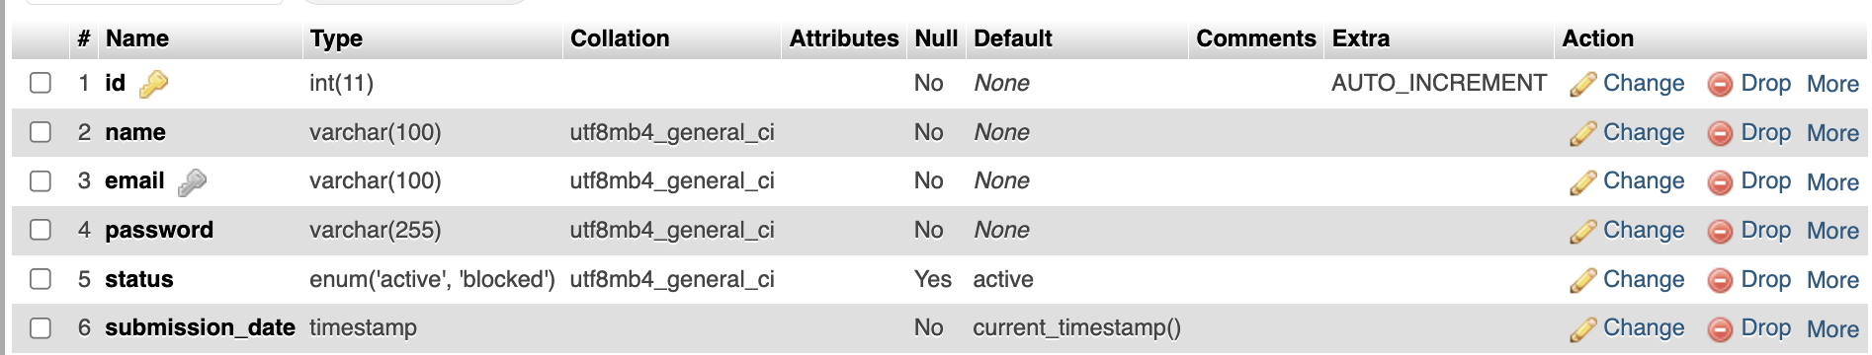

**2. contact_form_submissions Table**:

* **Description**: Stores data submitted through the Contact Us form on the website.

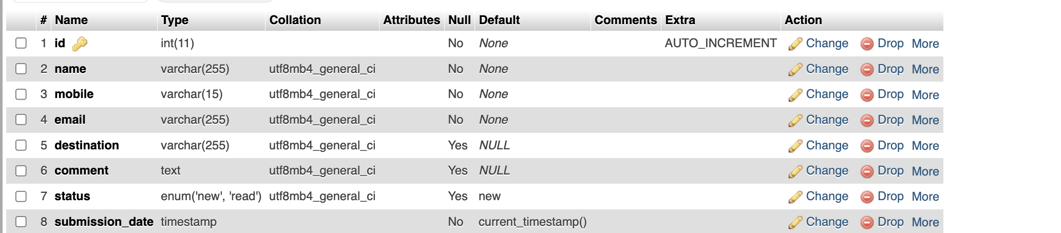

**3. bookings Table**:

* **Description**: Stores the booking information for tours made by registered users.

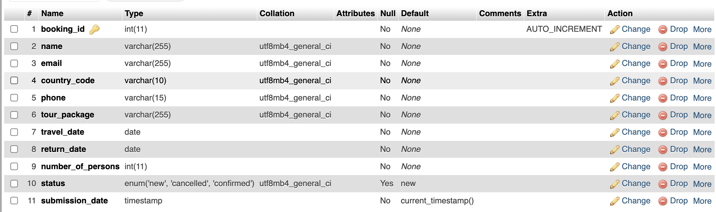

**4. tour_packages Table**:

* **Description**: Contains details of the tour packages offered on the website.

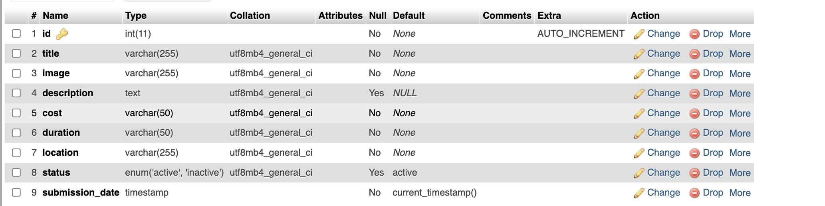

**5. content_package Table**:

* **Description**: Stores the detailed content and description of the specific tour packages. Linked to tour_packages via tour_id foreign key.

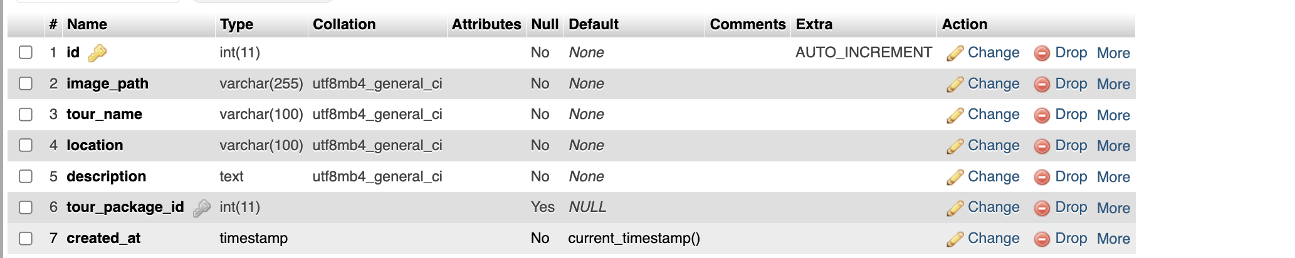

**6. Feedback Table:**

* **Description**: This table used insert feedback from user.

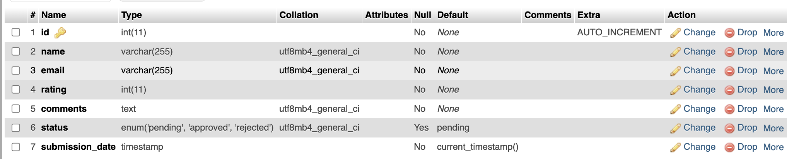

## 7.3 Screenshots

* **Header Section**

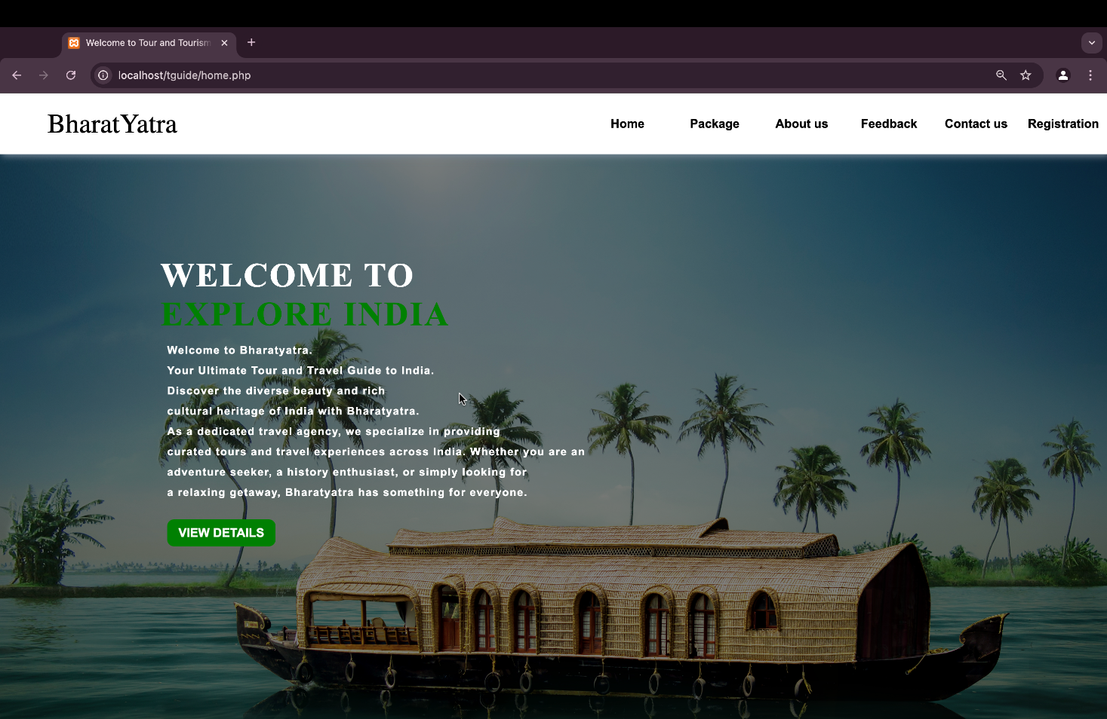

* **Index Section**

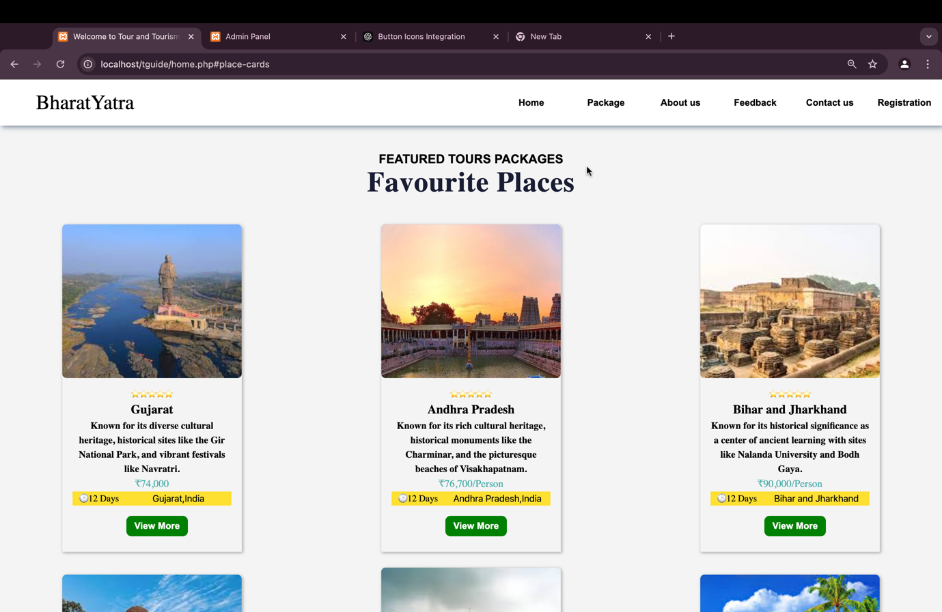

* **Footer Section**

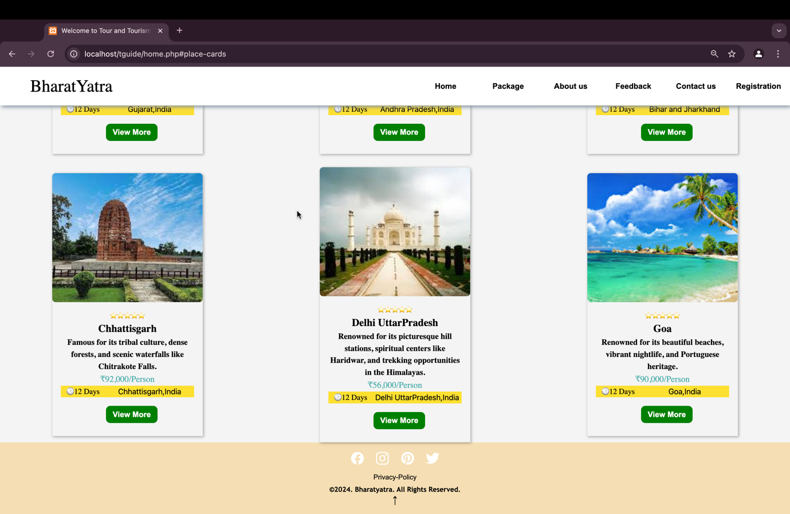

* **About Us**

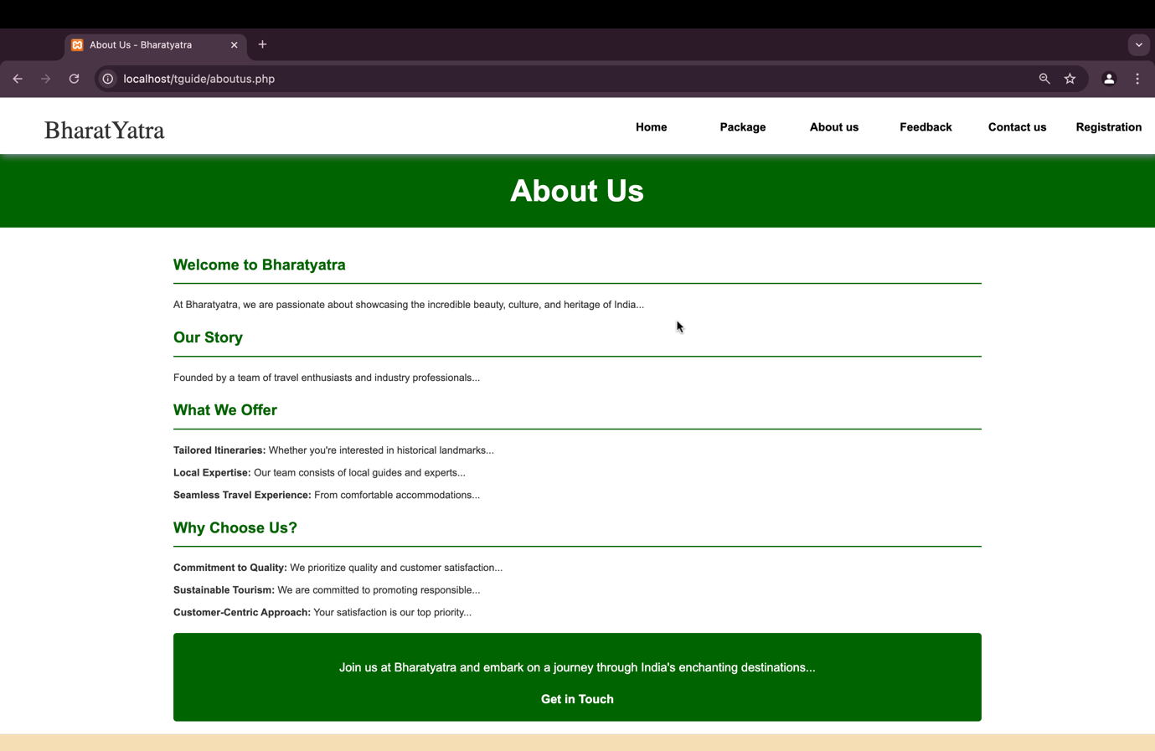

* **Contact Us**

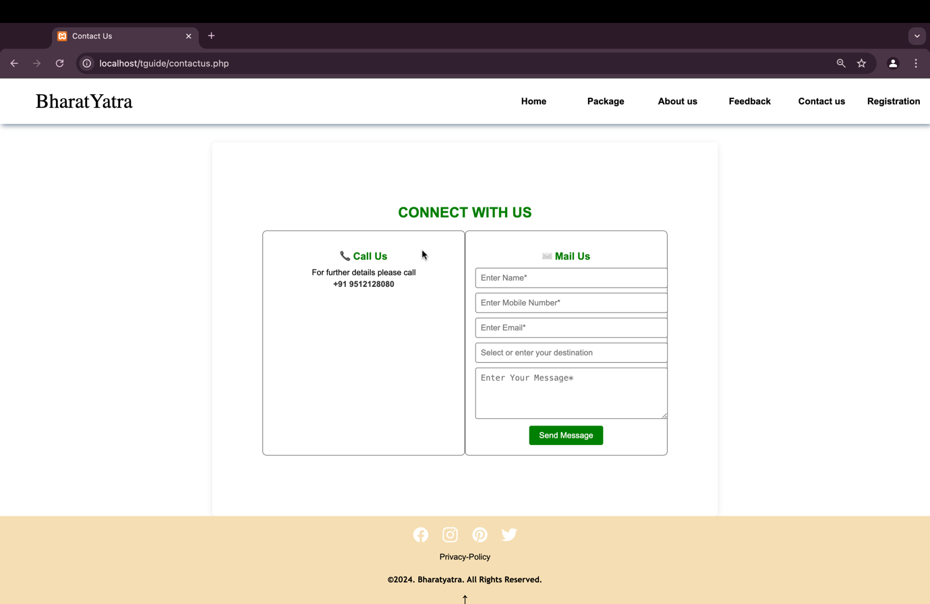

* **Privacy & Policy**

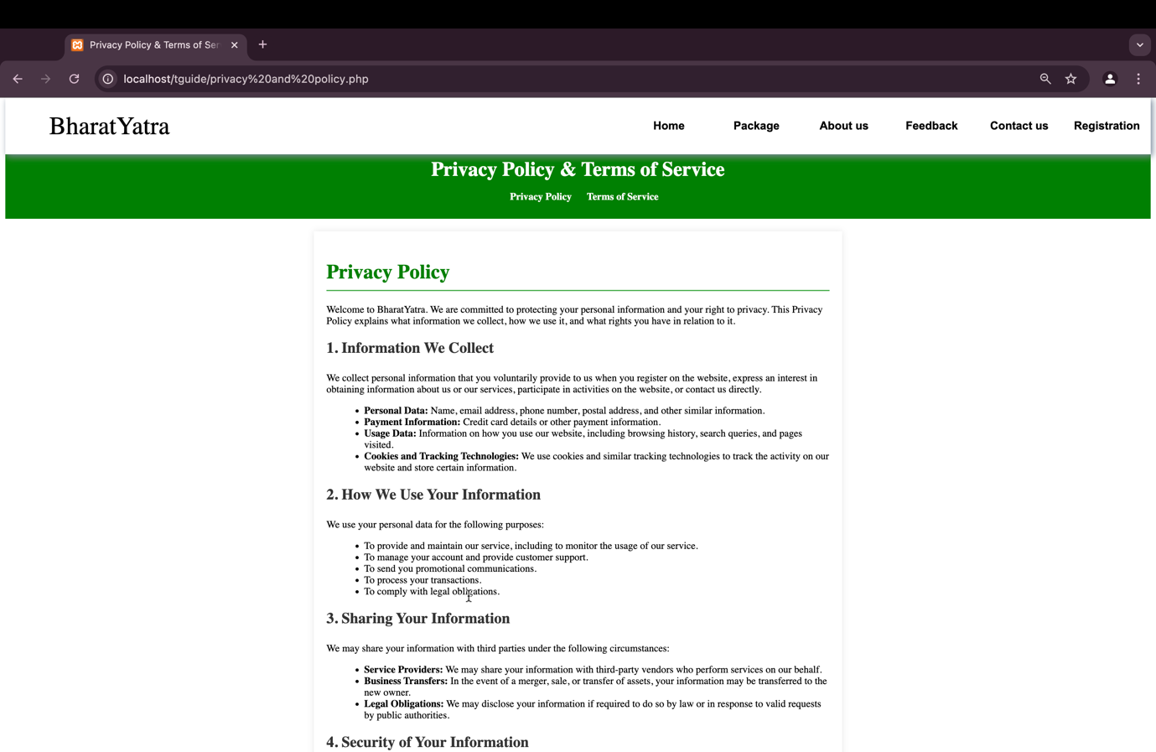

* **Sign Up**

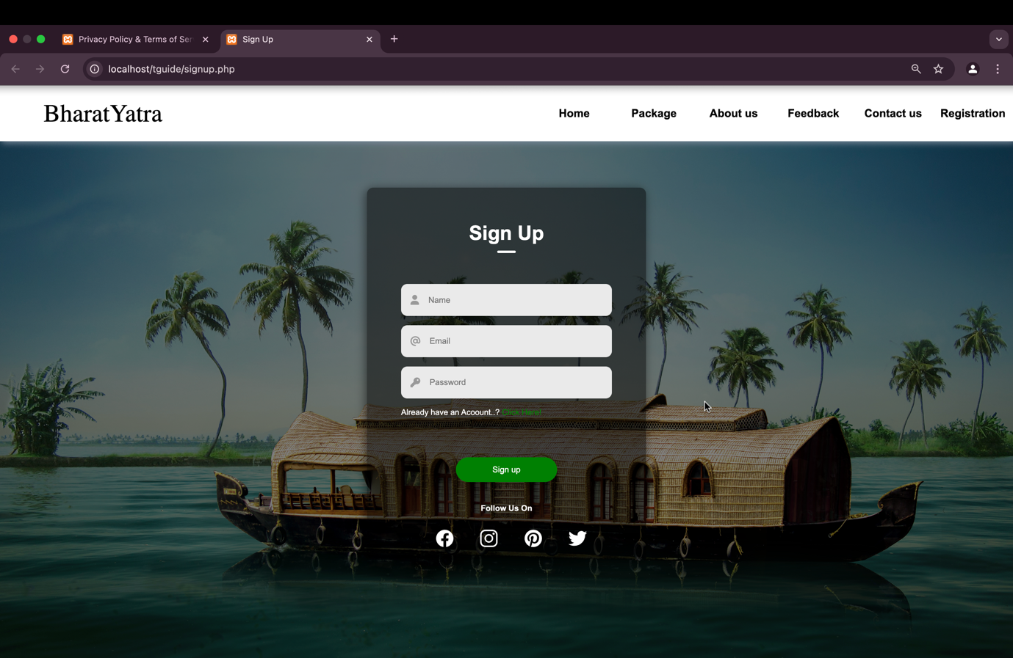

* **Sign In**

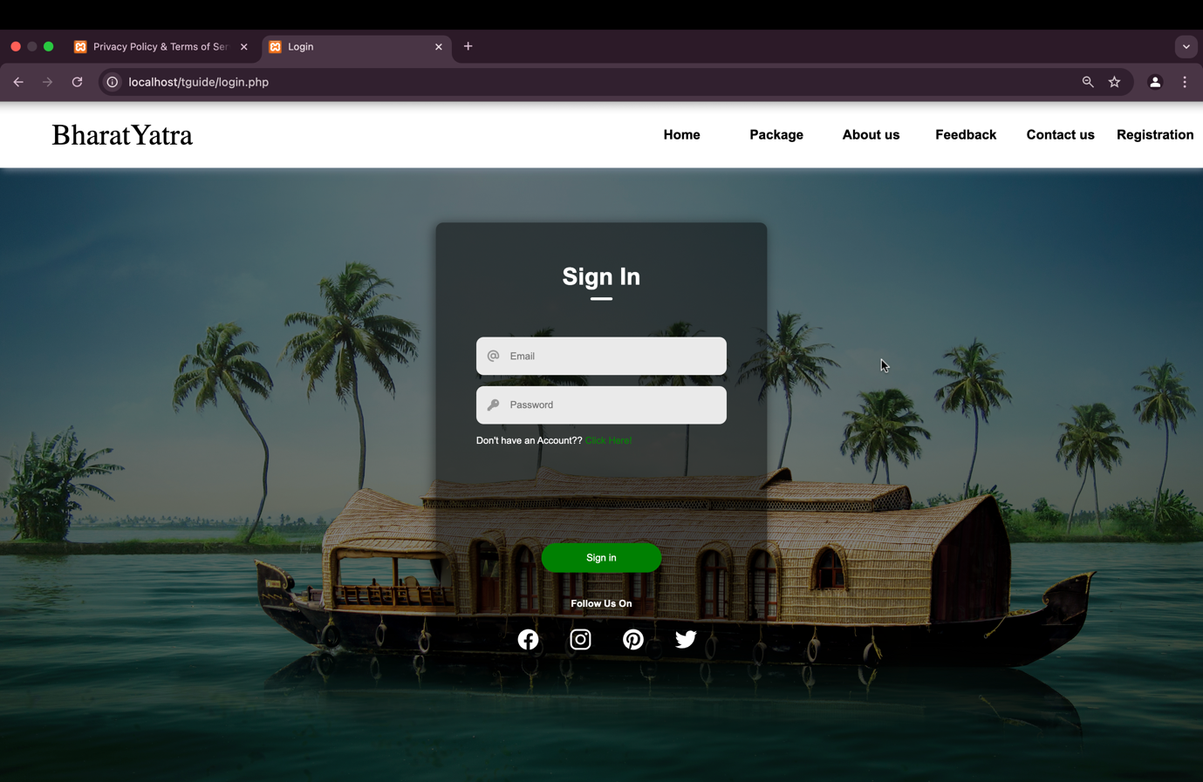

* **Package Description**

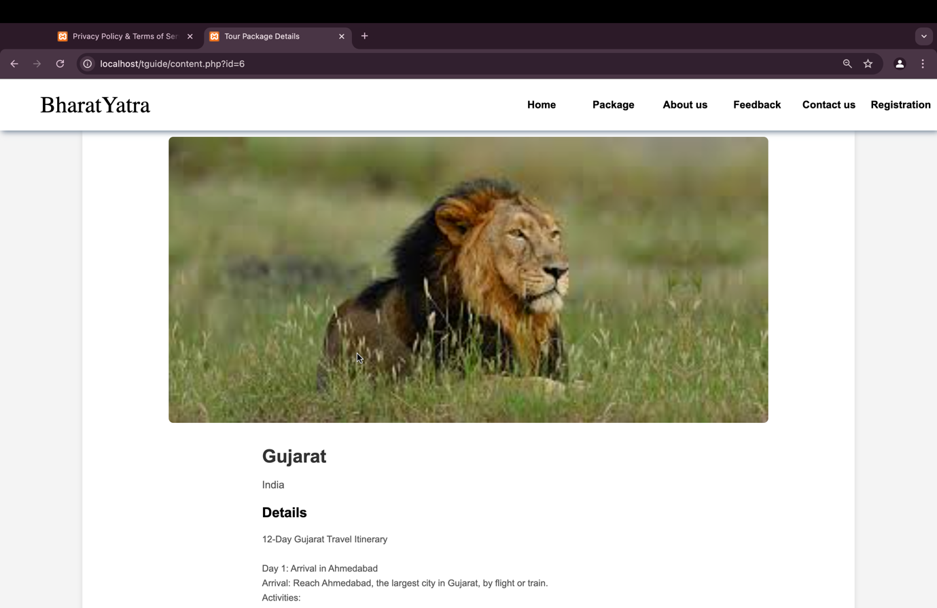

* **Booking Form**

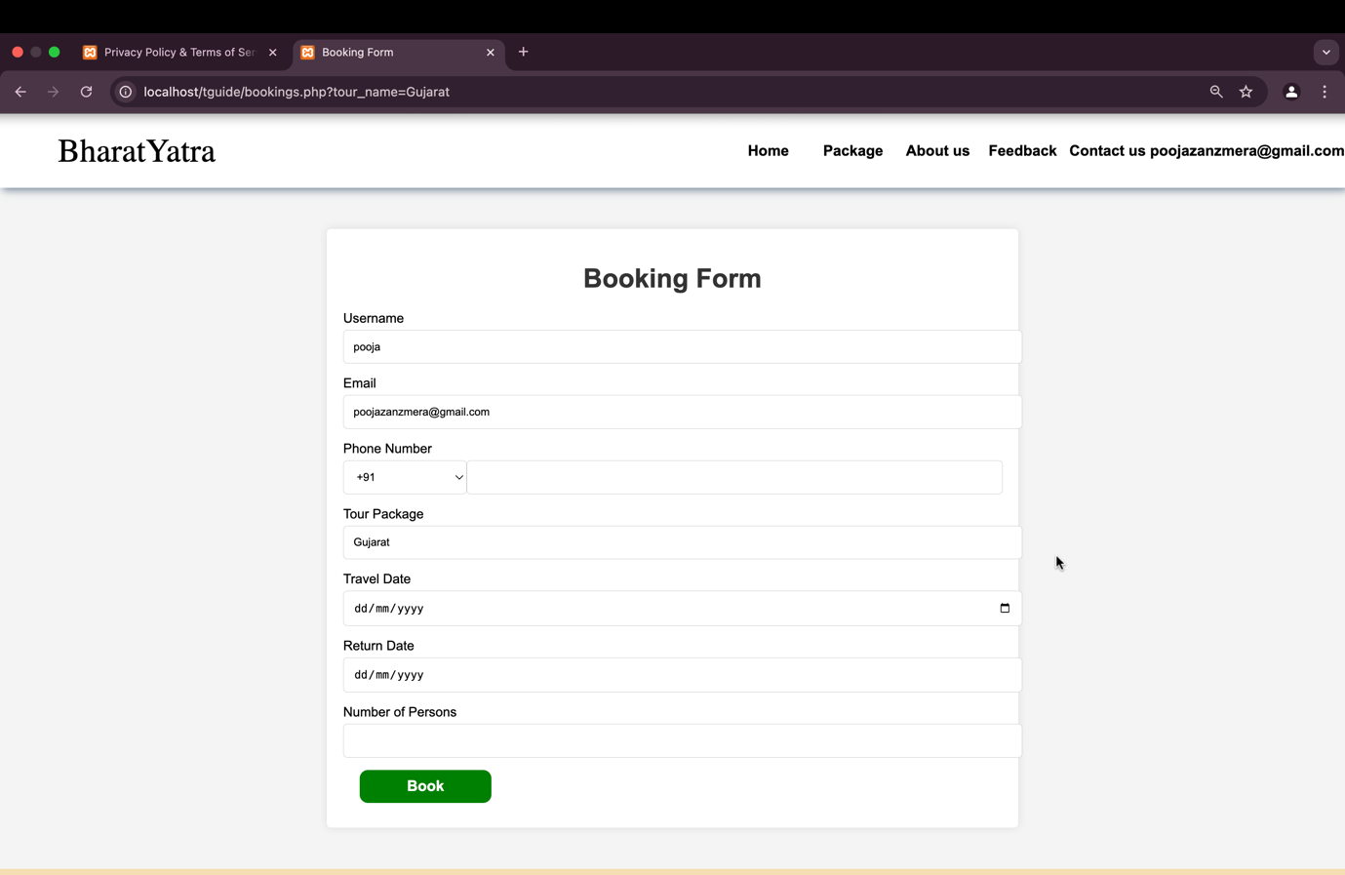

* **Confirmation**

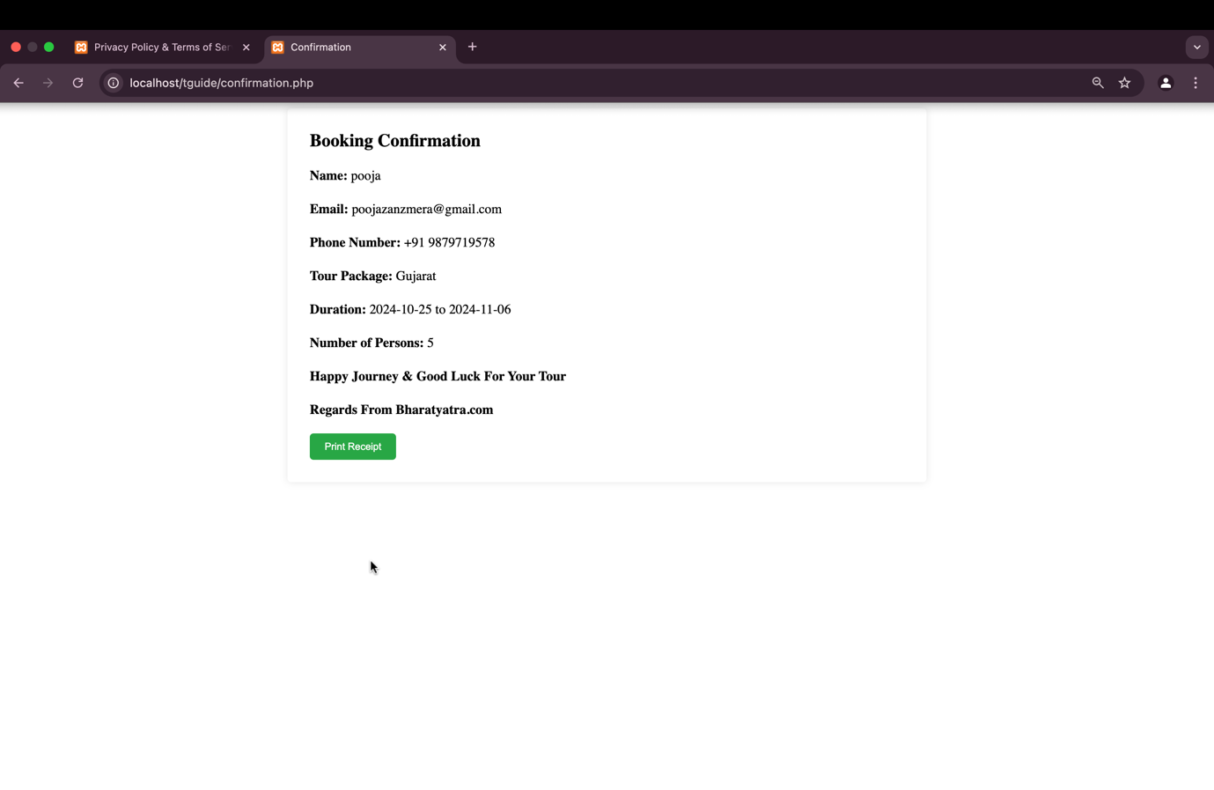

* **User Panel**

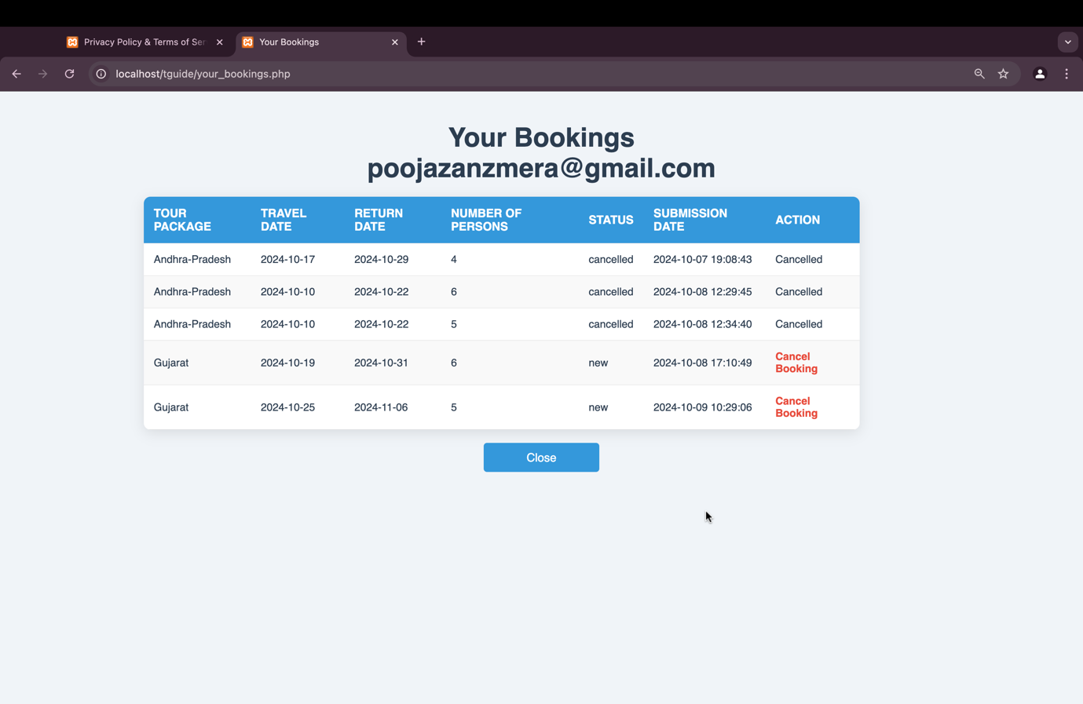

**Admin side screenshot:**

* **Admin-login**

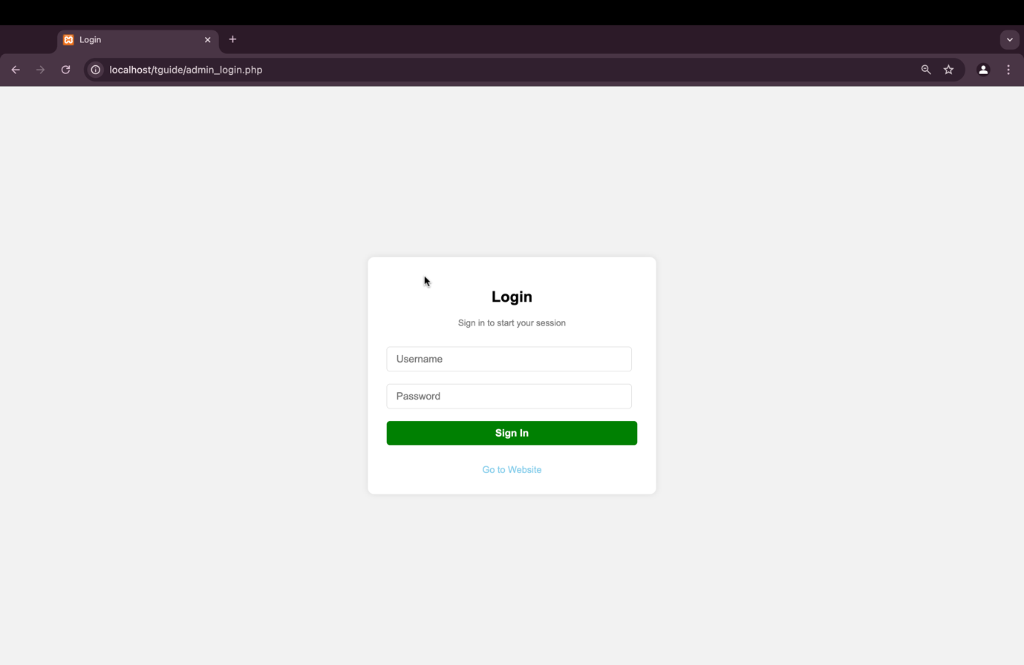

* **Admin-Dashboard**

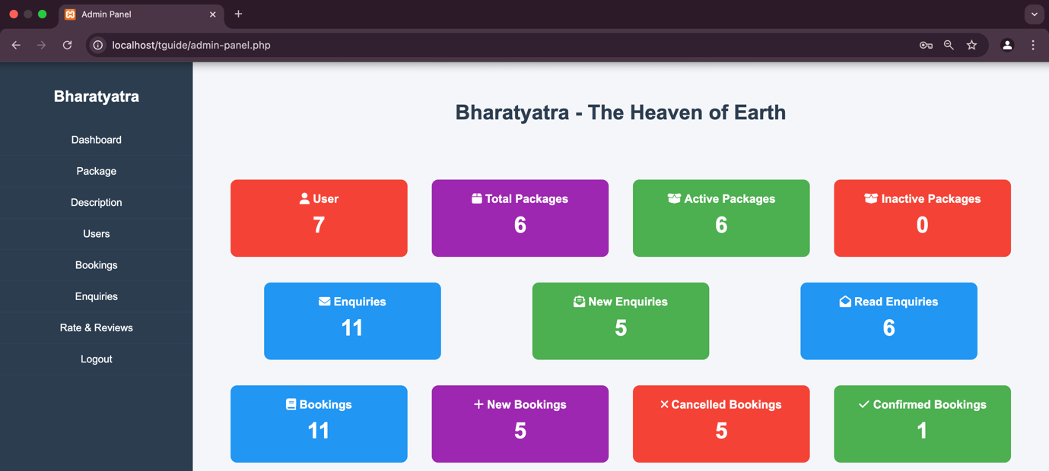

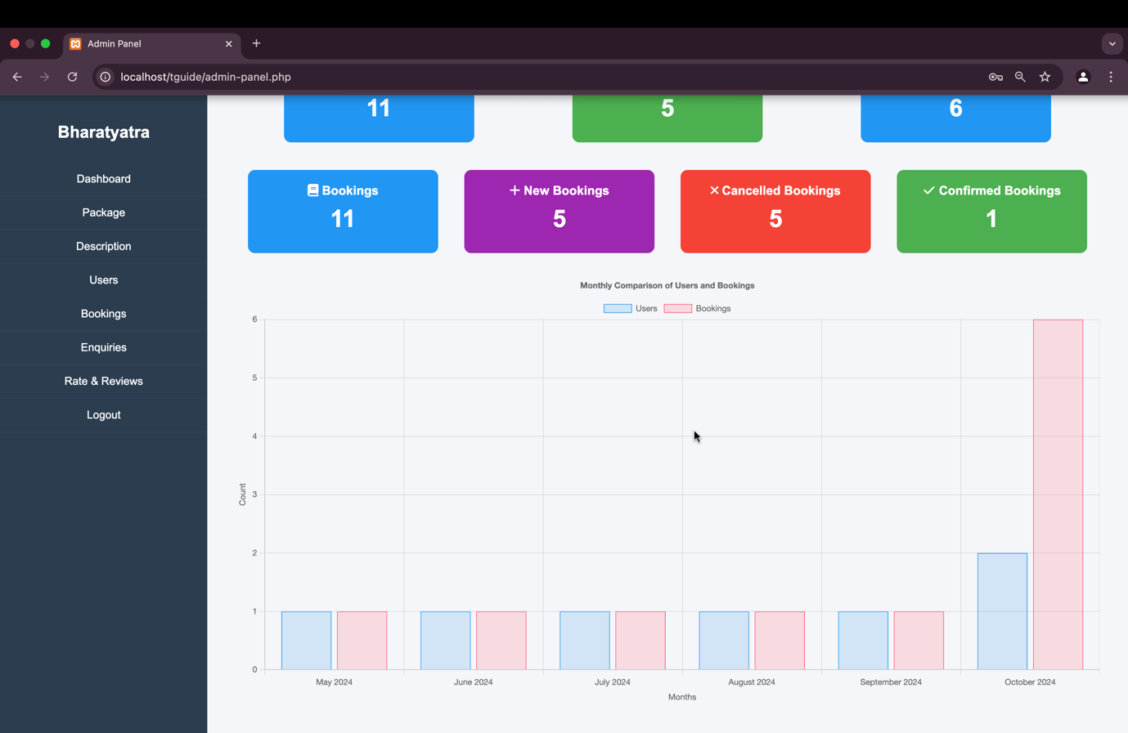

* **Package create and display**

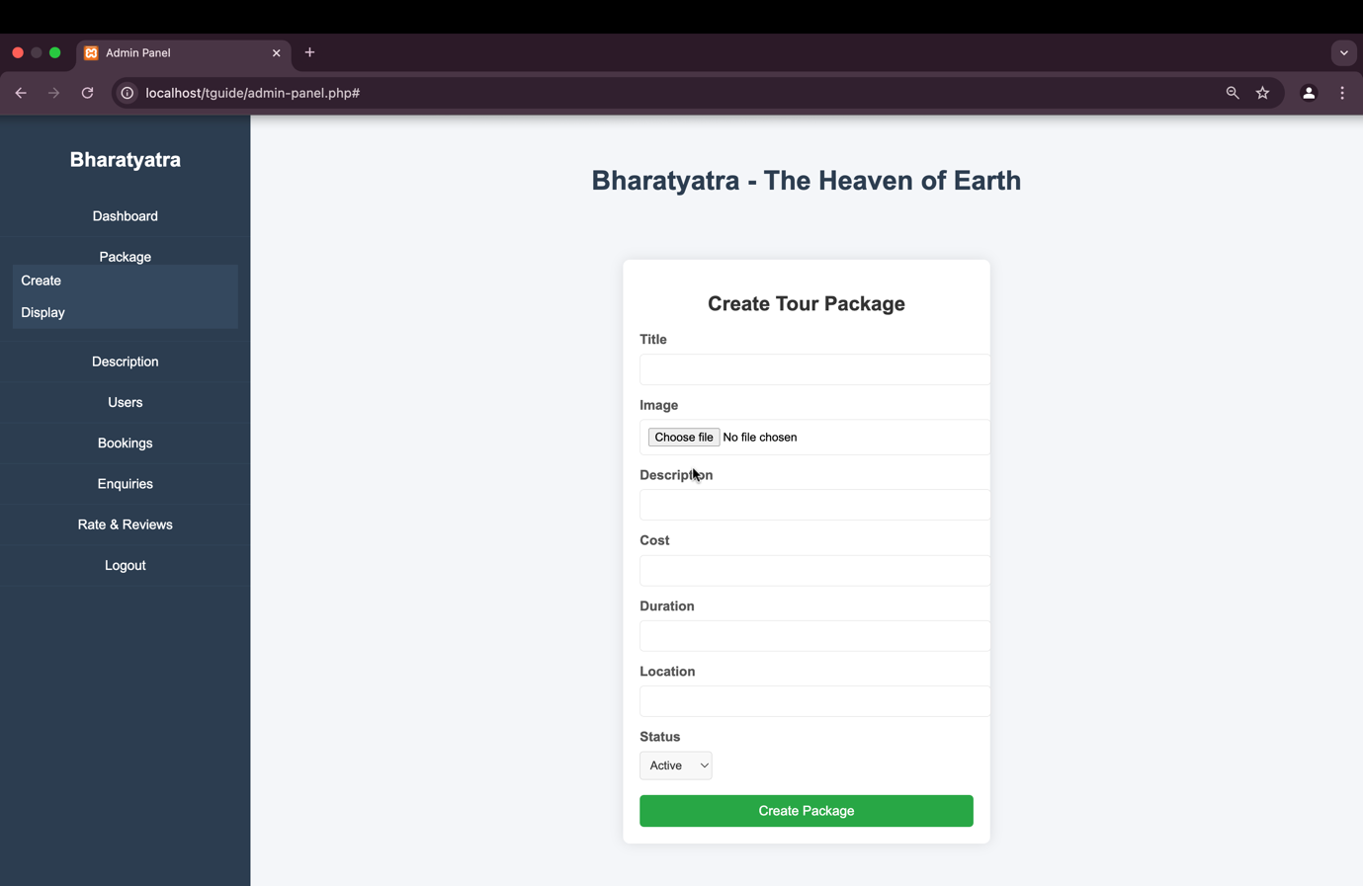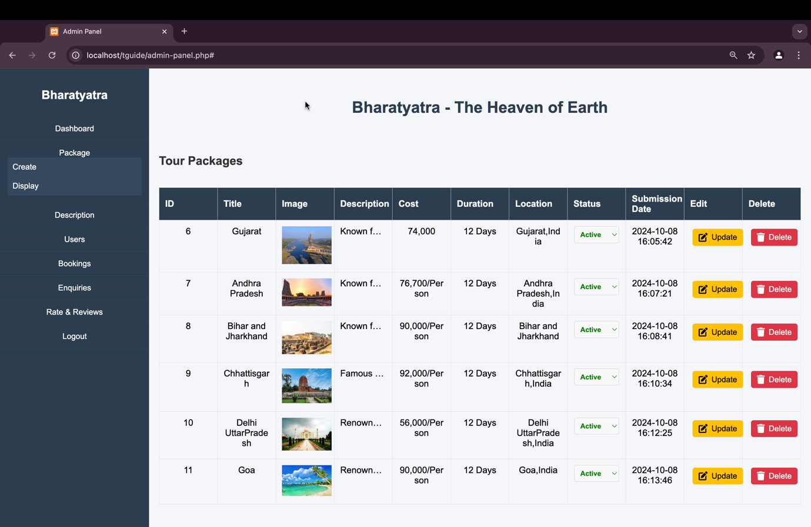

* **Content create and display**

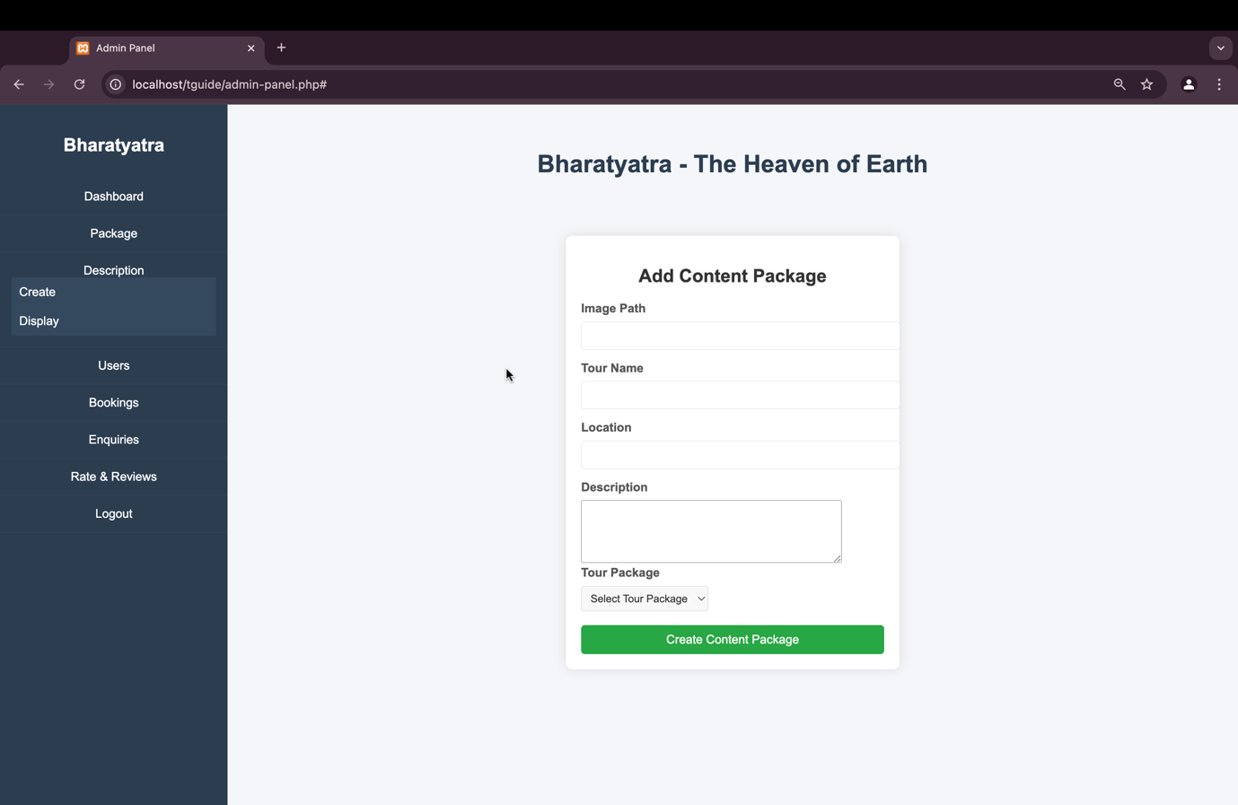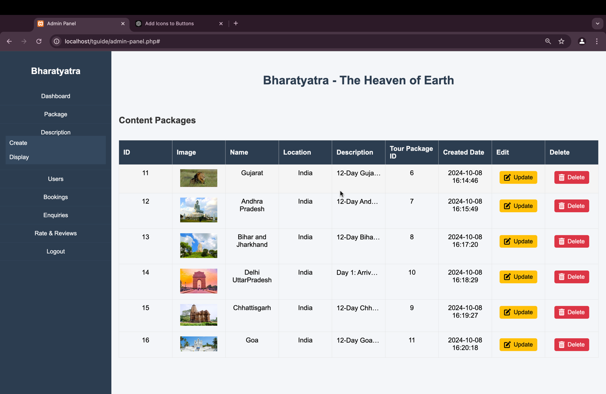

* **User**

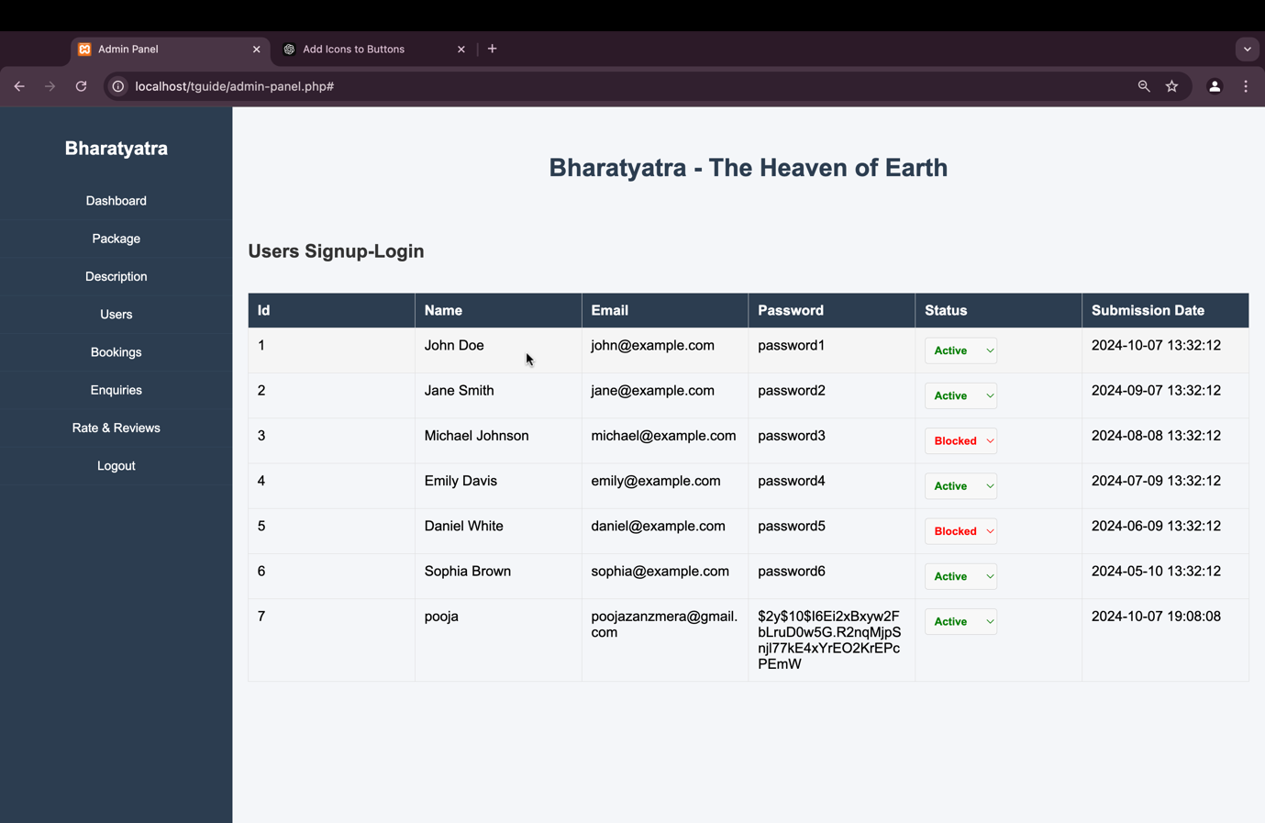

* **Bookings**

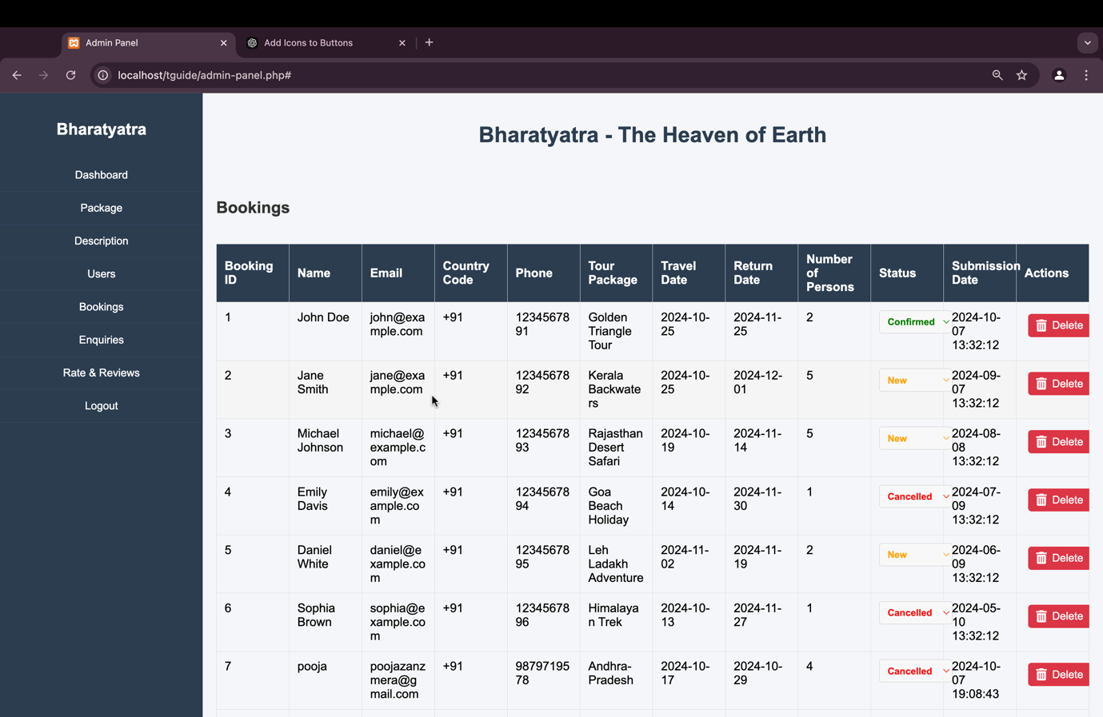

* **Enquiries**

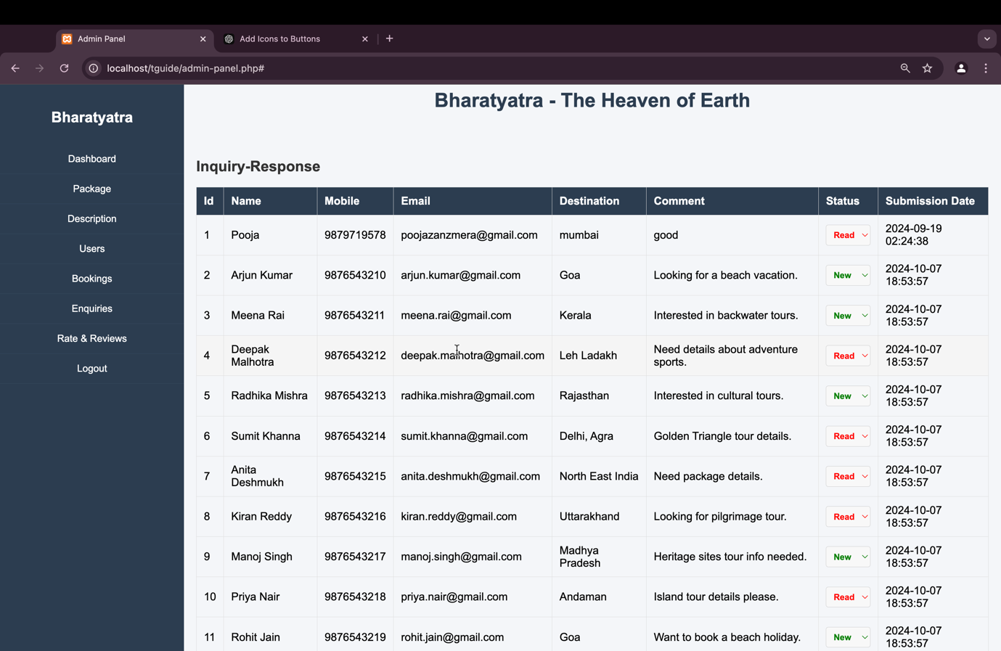

* **Rate & Reviews**

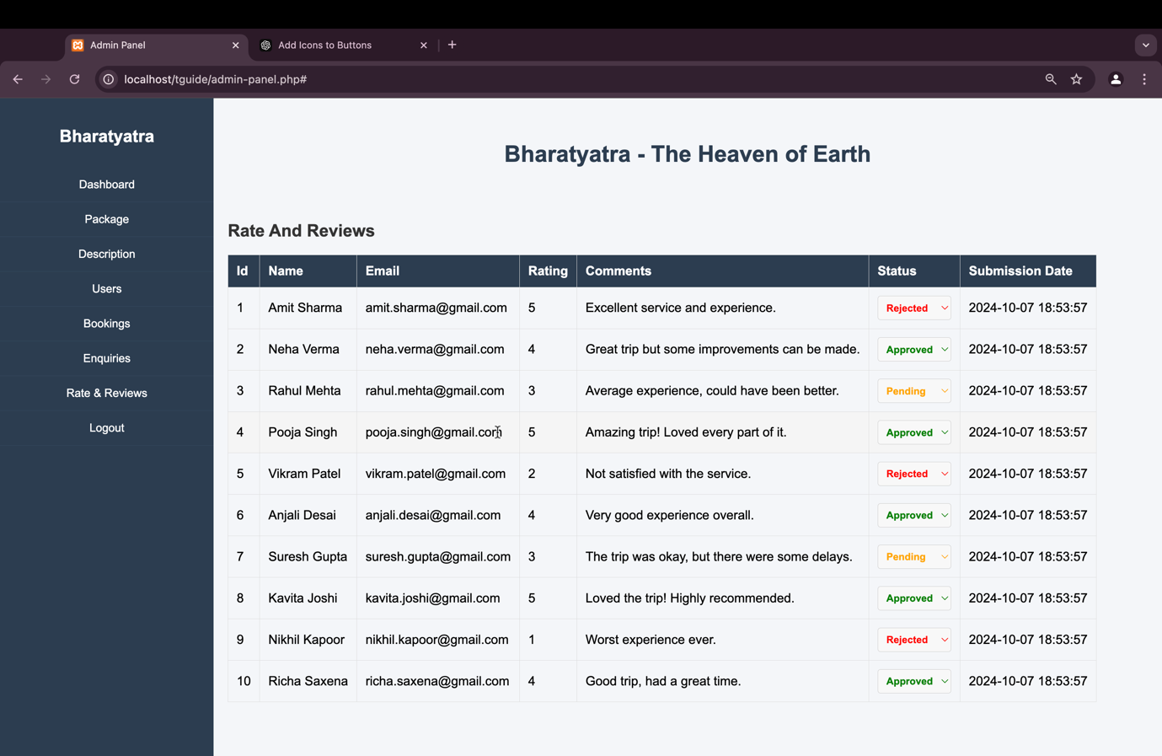

8.Software Testing

Software testing is a critical phase in the development process to ensure the "Tour and Tourism Guide" website functions as expected and meets both user and business requirements. Testing is conducted to identify any bugs, issues, or areas for improvement and verify that all features work correctly.

Testing for this website covers various aspects, including:

* **Functional Testing**: To ensure each feature of the website (user registration, login, tour booking, etc.) works as expected.
* **Usability Testing**: To confirm that users can easily navigate the site, access all features, and understand the functionality.
* **Performance Testing**: To check how the website behaves under different conditions, such as heavy traffic.
* **Security Testing**: To verify that user data is protected, and sensitive operations such as payment and booking are secure.

## 8.1 Test Case

A **test case** defines a specific set of inputs, execution conditions, and expected results to validate a particular feature of the website. Below are sample test cases for key functionalities in the "Tour and Tourism Guide" website:

**Test Case 1: User Registration**

| **Test Case ID** | **TC-01** |
| --- | --- |
| **Test Case Title** | User Registration Functionality |
| **Objective** | To verify that new users can successfully register. |
| **Pre-Conditions** | No user exists with the same email or username. |
| **Steps** | 1. Navigate to the registration page. 2. Fill out the registration form with valid details. 3. Click on "Register." |
| **Expected Result** | A new account should be created, and the user should be redirected to the login page. |
| **Actual Result** | To be filled after execution. |
| **Pass/Fail** | To be filled after execution. |

**Test Case 2: User Login**

| **Test Case ID** | **TC-02** |
| --- | --- |
| **Test Case Title** | User Login Functionality |
| **Objective** | To verify that a registered user can successfully log in. |
| **Pre-Conditions** | User account already exists. |
| **Steps** | 1. Navigate to the login page. 2. Enter valid email and password. 3. Click on "Login." |
| **Expected Result** | The user should be successfully logged in and redirected to the homepage. |
| **Actual Result** | To be filled after execution. |
| **Pass/Fail** | To be filled after execution. |

**Test Case 3: Tour Package Viewing**

| **Test Case ID** | **TC-03** |
| --- | --- |
| **Test Case Title** | Viewing Tour Package Details |
| **Objective** | To verify that users can view details of a tour package. |
| **Pre-Conditions** | User is on the homepage or package listing page. |
| **Steps** | 1. Click on a tour package. 2. View the tour details, including itinerary, price, and availability. |
| **Expected Result** | The user should be able to see all the relevant details of the selected tour. |
| **Actual Result** | To be filled after execution. |
| **Pass/Fail** | To be filled after execution. |

**Test Case 4: Booking a Tour Package**

| **Test Case ID** | **TC-04** |
| --- | --- |
| **Test Case Title** | Booking a Tour Package |
| **Objective** | To verify that users can successfully book a tour package after logging in. |
| **Pre-Conditions** | The user is logged in, and the package is available for booking. |
| **Steps** | 1. Select a tour package. 2. Click on "Book Now." 3. Complete the booking form. 4. Click on "Submit." |
| **Expected Result** | The booking should be successful, and the user should receive a confirmation with a booking receipt. |
| **Actual Result** | To be filled after execution. |
| **Pass/Fail** | To be filled after execution. |

**Test Case 5: Contact Us Form Submission**

| **Test Case ID** | **TC-05** |
| --- | --- |
| **Test Case Title** | Contact Us Form Submission |
| **Objective** | To verify that the "Contact Us" form submissions are saved correctly in the database. |
| **Pre-Conditions** | The user is on the contact page. |
| **Steps** | 1. Navigate to the contact form. 2. Enter valid information (name, email, message). 3. Submit the form. |
| **Expected Result** | The form submission should be saved in the contact_form_submissions table, and a confirmation message should be displayed. |
| **Actual Result** | To be filled after execution. |
| **Pass/Fail** | To be filled after execution. |

9. Conclusion and future enhancement

The "Tour and Tourism Guide" website offers a comprehensive platform for users to explore, plan, and book tours across India, whether for state-wise or all-India tours. The system is designed with user-friendliness and flexibility in mind, ensuring that users can access detailed tour-related information such as day-to-day itineraries, accommodation, food, transportation, and total tour cost. It also includes robust features like user registration and login, secure booking, and detailed booking receipts.

The website effectively addresses the existing challenges in the travel and tourism sector by providing the following solutions:

* **Comprehensive Destination Coverage**: Covers both popular and rare, offbeat destinations.
* **Transparent Budgeting**: Offers a clear breakdown of all tour expenses, making it easier for users to plan tours according to their budget.
* **Efficient Booking Process**: Simplifies the process of booking tours through a well-validated and secure system.
* **Performance Optimization**: Improves on the performance issues found in similar platforms, ensuring a smoother experience for users.

This project also establishes a strong foundation for future enhancements, particularly in terms of expanding services and improving user experience.

#### **Future Enhancements:**

While the current version of the "Tour and Tourism Guide" website offers a robust system for users to explore and book tours, there is always room for future improvements and added features to enhance the user experience. Some potential areas of future enhancements include:

1. **Integration of Real-Time Booking Systems**:
   * The current system could be improved by integrating real-time booking systems with third-party vendors for flights, trains, and hotel reservations. This would allow users to book not just tours, but the entire travel experience directly from the platform.
2. **Payment Gateway Integration**:
   * While the system provides receipt generation after booking, adding a secure, built-in payment gateway integration would allow users to make payments directly from the platform. This enhancement would streamline the booking process by eliminating the need for external payment steps.
3. **User Reviews and Ratings**:
   * A review and rating system can be introduced for users to provide feedback on the tours they’ve booked. This will not only help other users make informed decisions but also provide valuable insights for improving the quality of the tours offered.
4. **Dynamic Pricing and Discounts**:
   * The system can incorporate dynamic pricing based on factors such as demand, season, or early bookings. Additionally, promotional offers and discounts can be provided to encourage more bookings during the off-season or for early birds.
5. **Mobile Application**:
   * Expanding the platform to a mobile application would provide greater accessibility for users, enabling them to browse and book tours on the go. With the increasing use of mobile devices, having a dedicated app would significantly enhance the user experience.
6. **Advanced Search and Filters**:
   * Adding advanced search filters (such as tour type, price range, duration, difficulty level, etc.) would help users find tours that match their specific preferences more easily.
7. **Multi-Language Support**:
   * As India is a linguistically diverse country, providing multi-language support would cater to a broader user base. Users would be able to access the website in their preferred language, enhancing accessibility and inclusivity.
8. **Personalized Recommendations**:
   * By leveraging machine learning, the system could offer personalized tour recommendations based on user preferences, past bookings, and browsing history. This feature would improve user engagement and help them find tours that match their interests.
9. **Social Media Integration**:
   * Adding the ability to share tour details or experiences on social media platforms can increase the visibility of the website. Social media sharing buttons or links can make the platform more engaging.
10. **Customer Support Chatbot**:
    * Implementing a customer support chatbot that can assist users with booking queries or tour-related questions would improve the overall user experience. This feature would provide 24/7 support without requiring human intervention.

10. References

• **PHP Documentation**:

Official PHP Documentation for understanding core PHP functions and syntax.

URL: <https://www.php.net/docs.php>

• **MySQL Documentation**:

MySQL Reference Manual for understanding database queries, relational database design, and optimizing database performance.

URL: <https://dev.mysql.com/doc/>

• **W3Schools - PHP and MySQL Tutorials**:

Comprehensive tutorials on PHP and MySQL for web development, including CRUD operations, sessions, and validation.

URL: <https://www.w3schools.com/>

• **XAMPP Official Site**:

XAMPP installation and configuration guide, used for setting up the local development environment for the "Tour and Tourism Guide" website.

URL: <https://www.apachefriends.org/>

• **Bootstrap Documentation**:

Documentation for using the Bootstrap front-end framework for responsive design and layout structuring.

URL: <https://getbootstrap.com/docs/>

• **Stack Overflow**:

A community-driven platform for solving programming challenges, including PHP, MySQL, and front-end issues encountered during the development process.

URL: <https://stackoverflow.com/>

• **Tour and Travel Industry Websites**:

Websites like holidaynights.com and tourmyindia.com were reviewed for comparison purposes to identify gaps in the market and opportunities for improvement.

<https://www.holidaynights.com>

<https://www.tourmyindia.com>

• **Visual Studio Code Documentation**:

Resources for configuring and using Visual Studio Code, the IDE used in this project.

URL: <https://code.visualstudio.com/docs>

• **UML Diagrams and ER Diagrams Resources**:

For understanding and creating UML and ER diagrams, key in system planning and design.

UML: <https://www.uml-diagrams.org/>

ERD: <https://www.visual-paradigm.com/guide/data-modeling/what-is-entity-relationship-diagram/>

• **Online Security Guidelines for Web Development**:

Best practices for ensuring secure data handling and user authentication in web applications. URL: <https://owasp.org/>